33rd Annual Joint Meeting of the ENIC-NARIC Networks

24-26 May 2026

Athens, Greece

Practical Information

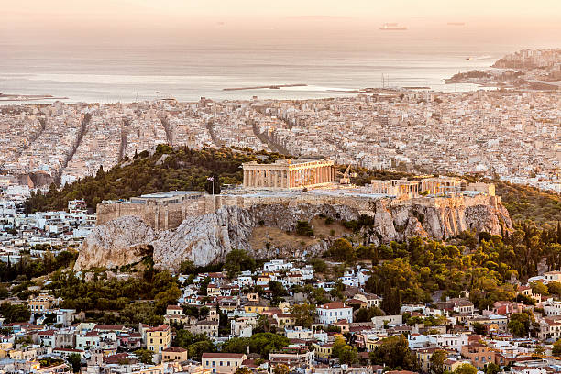

Meeting dates and venues

- Sunday 24 May, networking activity, visit to the Temple of Poseidon on Cape Sounion, 9:00-14:30. Details of the meeting point will be shared in early May.

Accessibility limitations: The path to the temple is partly accessible for wheelchair users, and there is a viewing platform with a view of the temple. Visitors with limited mobility can use the path with assistance, and all visitors are strongly advised to wear comfortable shoes and avoid high heels.
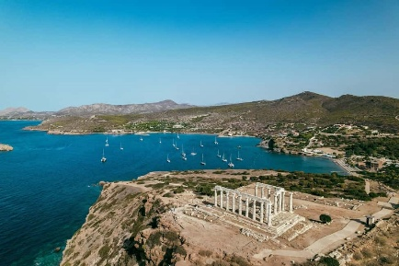

- Sunday 24 May, Registration at 17:00, Social Programme 17:30-19:30 at the Acropolis Museum, Auditorium "Dimitrios Pantermalis” (Dionysiou Areopagitou 15, Athens) followed by a welcome cocktail at Aigli Zappeiou (Zappeion Garden) from 20:00-22:00.

Note that, although there is no accessibility limitation, comfortable footwear is recommended.
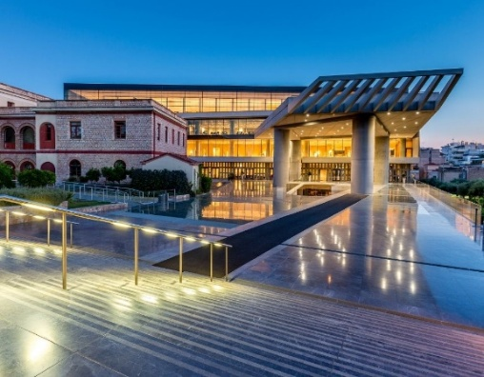

- Monday 25 May | 1st meeting day, 09:00-17:10
- Tuesday 26 May | 2nd meeting day, 09:00-14:00
Stavros Niarchos Foundation Cultural Center (SNFCC)
(364 Andrea Syggrou Ave., Kallithea)

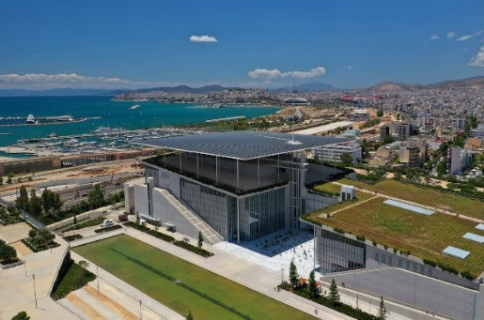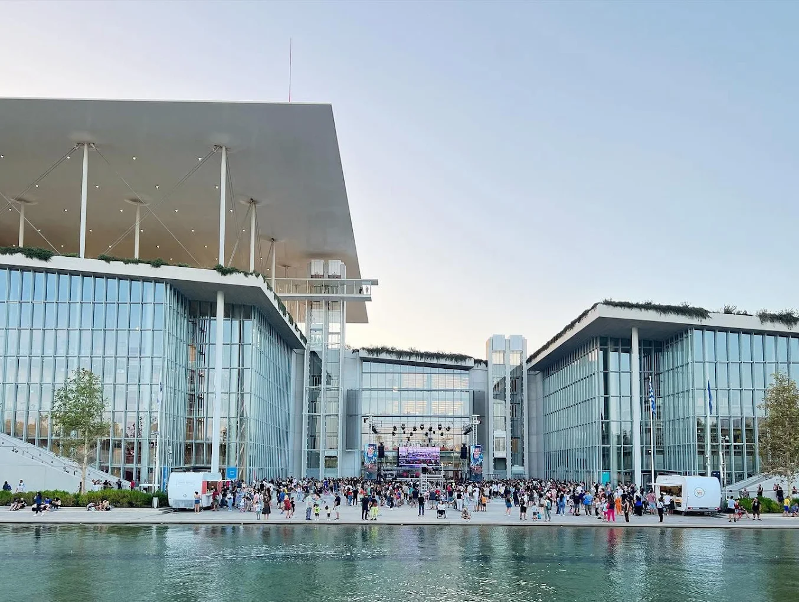
- Monday 25 May | dinner
19:30-23:00: Ble Pavillon (70 Posidonos Ave., Alimos)

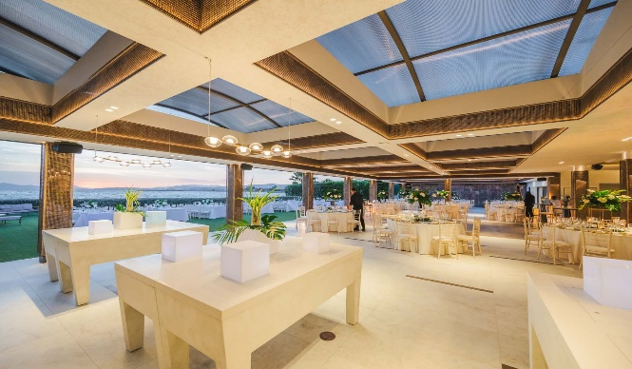

Venues on the map

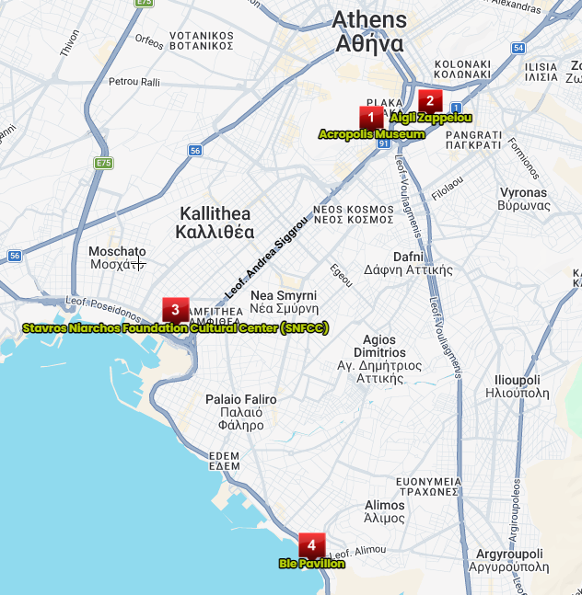 |   Scan QR-code  to view the map

Accommodation
Since May is peak season, we recommend booking accommodation as early as possible. Every participant is responsible for his/her own hotel booking. The following hotels are nearby SNFCC:

AVA Hotel & Residences Athens Riviera (500m from SNFCC),
238 Doiranis St, Kallithea (to secure a 15% discount, send an email to residences@avahotel.gr referring to “33rd Annual Joint Meeting of the ENIC and NARIC Networks” and DOATAP)

Andromeda Park Suites **** (500m from SNFCC), 42 Evripidou St., Kallithea

10 Apartments and Suites **** (650m from SNFCC), 229 Sokratous St, Kallithea

Athens Marriott Hotel ***** (750m from SNFCC),
385 Andrea Syggrou Ave., Palaio Faliro

The Convo Athens Riviera ** (1100m from SNFCC, 15 mins walk)
336 Eleftheriou Venizelou, Kallithea

Hilton Garden Inn Athens Syggrou Avenue **** (2Km from SNFCC, 15 mins, combination of bus (every 8 mins) and walk), 234 Andrea Syggrou Ave., Kallithea

Athenaeum Grand Hotel **** (3.1Km from SNFCC,17 mins, combination of bus (every 9 mins) and walk), 142 Andrea Syggrou Ave., Kallithea

Athens Hill Luxury Apartments**** (3.3Km from SNFCC, 22 mins, combination of bus (every 9 mins) and walk), 40 Al. Pantou St., Kallithea (reserve directly on the official website www.athenshill.com using code ENN)

B4B Athens 365 Hotel *** (3.8Km from SNFCC, 17 mins, combination of bus (every 9 mins) and walk), 1 Fragkoudi St., Kallithea

Heritage Hill Hotel **** (4km from SNFCC, 21 mins, combination of bus every 3 min and walk), 61 Leoforos Andrea Siggrou, Athens (for best available rates, send email to info@hhhotel.gr referring to code: “33rd Annual Joint Meeting of the ENIC and NARIC Networks”)

Grand Hyatt Athens ***** (4.4Km from SNFCC, 20 mins, combination of bus (every 8 mins) and walk), 115 Andrea Syggrou Ave., Athens

Niche Hotel Athens **** (4.5Km from SNFCC, 25 mins, combination of bus and walk), 21 Andrea Syggrou Ave., Athens

The Athens Gate Hotel **** (4.7Km from SNFCC, 25 mins, combination of bus and walk), 10 Andrea Syggrou Ave., Athens

Royal Olympic ***** (4.9Km from SNFCC, 30 mins, combination of bus and walk), 28 Athanasiou Diakou St., Athens

Poseidon *** (4.5Km from SNFCC, 25 mins, combination of bus or tram and walk), 72 Posidonos Ave., Paleo Faliro

Coral **** (3.4Km from SNFCC, 22 mins, combination of bus or tram and walk),
35 Posidonos Ave., Athens (to receive a 10% discount, book directly through the website www.coralhotel.gr until 16.05.26 using code ENJM2026 in the voucher field).

Coco-Mat Athens BC ***** (4.9Km, 30 mins, combination of bus and walk),
5 Falirou St., Athens
All the options are located approximately 6-10mins from SNFCC by taxi with an estimated cost of 8€. Many other options for accommodation are nearby Acropolis.
Transportation

1)From/to Athens International Airport Eleftherios Venizelos (AIA)

The airport is located 30 km (19 miles) east of Athens. You may use public transportation, taxi or rent a car:

- METRO LINE 3 (Blue Line) connects the airport with Athens city center (ticket costs 9€). More information is available on stasy.gr.

- SUBURBAN RAILWAY takes you from the airport to Doukissis Plakentias Metro Stop (for more information on schedules, tickets and connections, you may consult the relevant link), then change to METRO LINE 3 towards Athens city center (one ticket for both costs 9€).

- EXPESS BUS LINE X95 connects the airport with Athens City Center (Syntagma square). For more information, you may visit the website Airport Express Bus Lines – OASA (one way costs 5.5€)

- TAXIS are available 24/7 at the designated Taxi waiting area located at Exit 3 of Arrivals Level. Taxi flat fares are designated for the routes from Athens Airport to Athens city center & vice versa (a flat fare of 40€ one way, daily from 05:00 - 24:00 and 55€ from 00:00 - 05:00). For more information, you may visit Taxi & Limousines .

- CAR RENTALS: at Athens airport, six car rental companies operate. Select the solution that suits you and get served at Arrivals level of the Main Terminal Building. For more information, you may visit Car Rentals .
2) From / to SNFCC

- Bus &Trolley Bus lines passing nearby SNFCC include: B2 or 910 or 550 from Syggrou Fix Metro stop, A2 from Syntagma Square, 040 from Syntagma Square combined with 550, trolley 10 etc.

- Taxis are yellow colored. You may reserve a taxi through an app (Free Now, Uber etc.) or flagging down one.
3) Public transport in the city centre

- For information on the Rail Transit System visit here.

- For real-time information on Buses and Trolleys check here .

Note that you can pay for your ticket by credit or debit card on all means of transport.
Meeting Agenda
The draft meeting agenda is being shared.

Registration
Registration opens on 23 May and closes on 30 April.

Visa
Visas are in the responsibility of the participants. Please ensure that you have a valid visa for your stay, if required. We are at your disposal to send an invitation letter for the event if needed for the visa request (enic-naric-2026@doatap.gr). Detailed information on visas and requirements for entering Greece are available on the website of Ministry of Foreign Affairs: https://www.mfa.gr/en/services/visas-for-foreigners-traveling-to-greece/

Climate
In May, the climate can vary. During this month, the average temperature is around 21°C / 69.8°F. We recommend wearing layers.

Pickpockets
Athens is a popular tourist destination. As for all places where tourists gather, you should pay attention to pickpockets, especially on public transportation and in busy areas.

Contacts
You can contact the organizers at DOATAP via enic-naric-2026@doatap.gr.

